Disha Dipak Bhave (19004)

**Project: Georeferencing**

**Aim:** To georeference arial image.

* Go to Web Menu → OpenLayerPlugin → OpenStreetMap→ OpenStreetMap

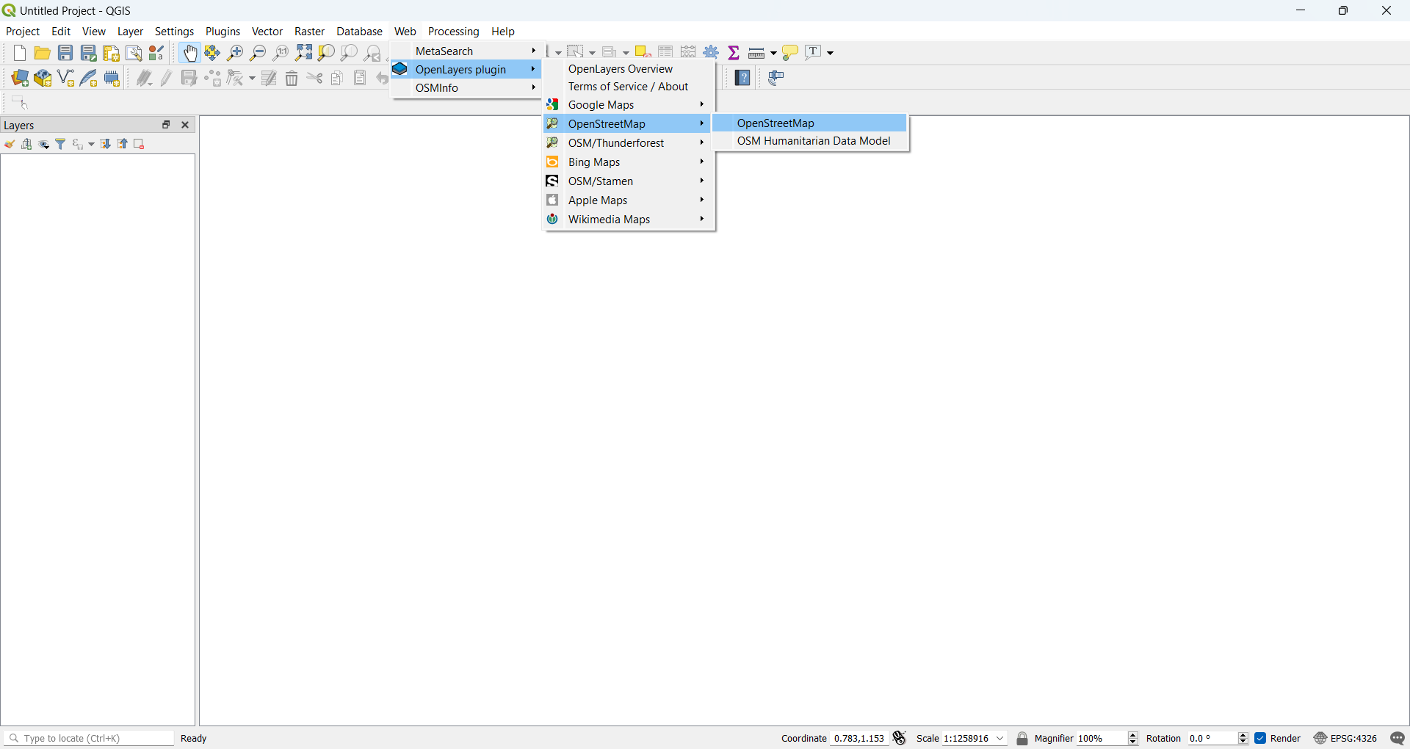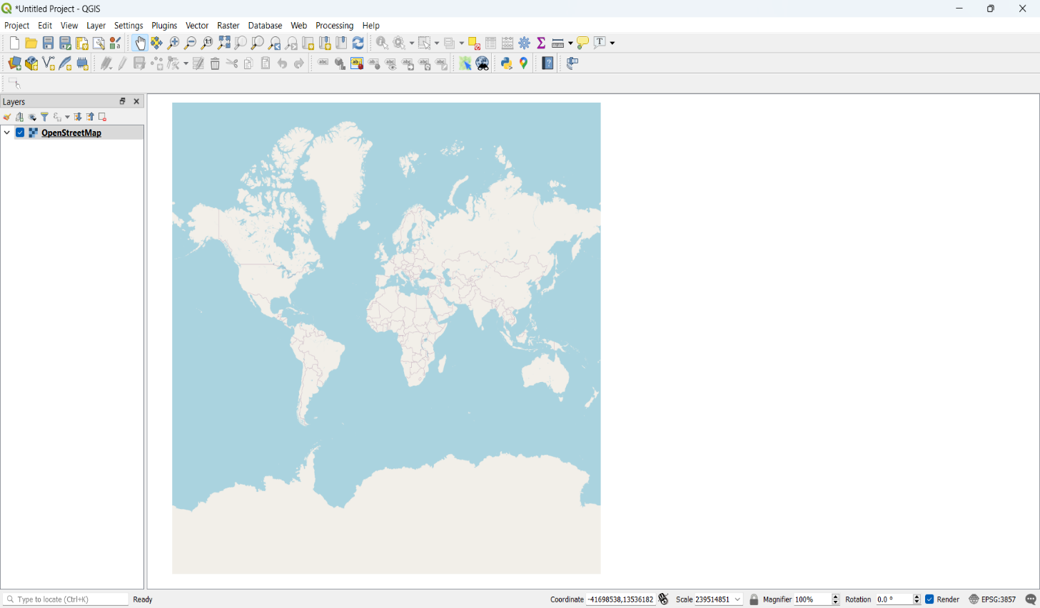

* Go to Project → Properties → Set CRS to EPSG 3857
* Go to View → Panels → select OSM Place search

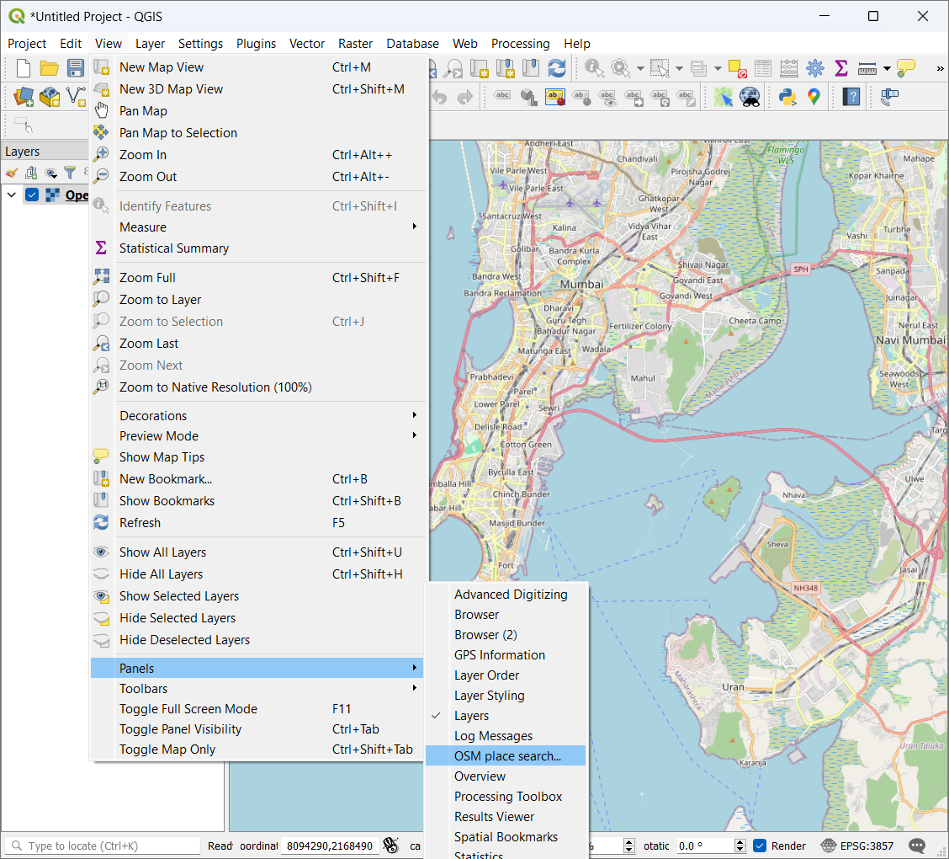

* The Gateway of India, Mumbai is located at 18.92°N 72.83°E
* Search Gateway of India in OSM Search Panel

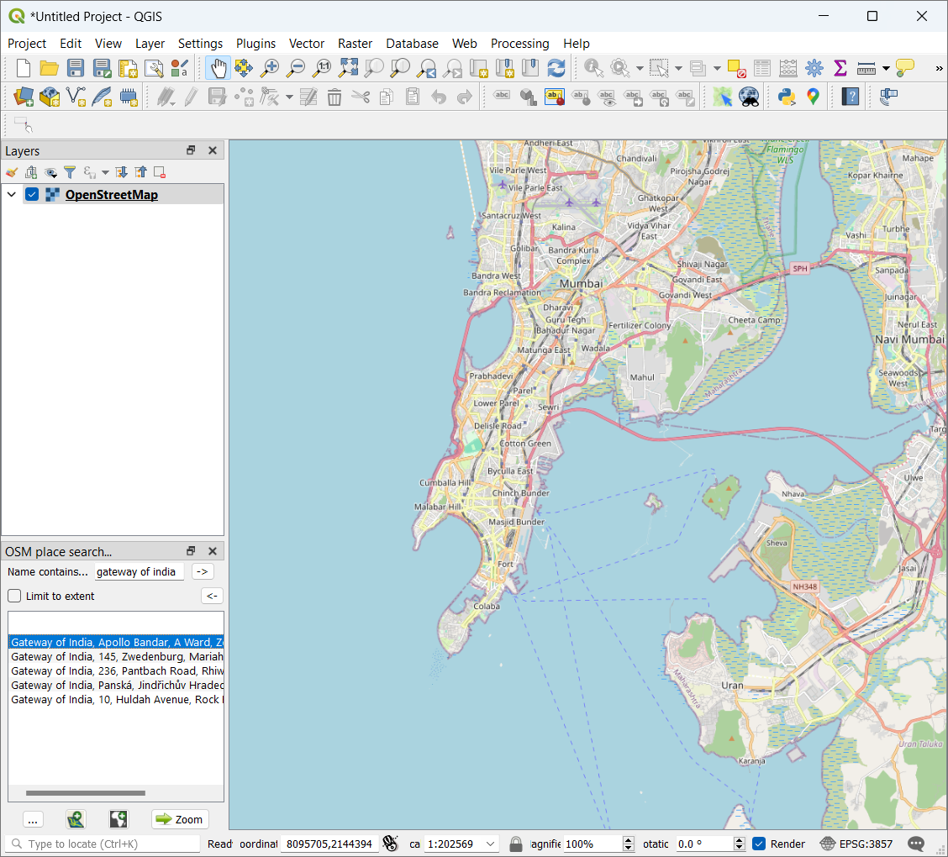

* Zoom in to appropriate level.
* The map will appear like this

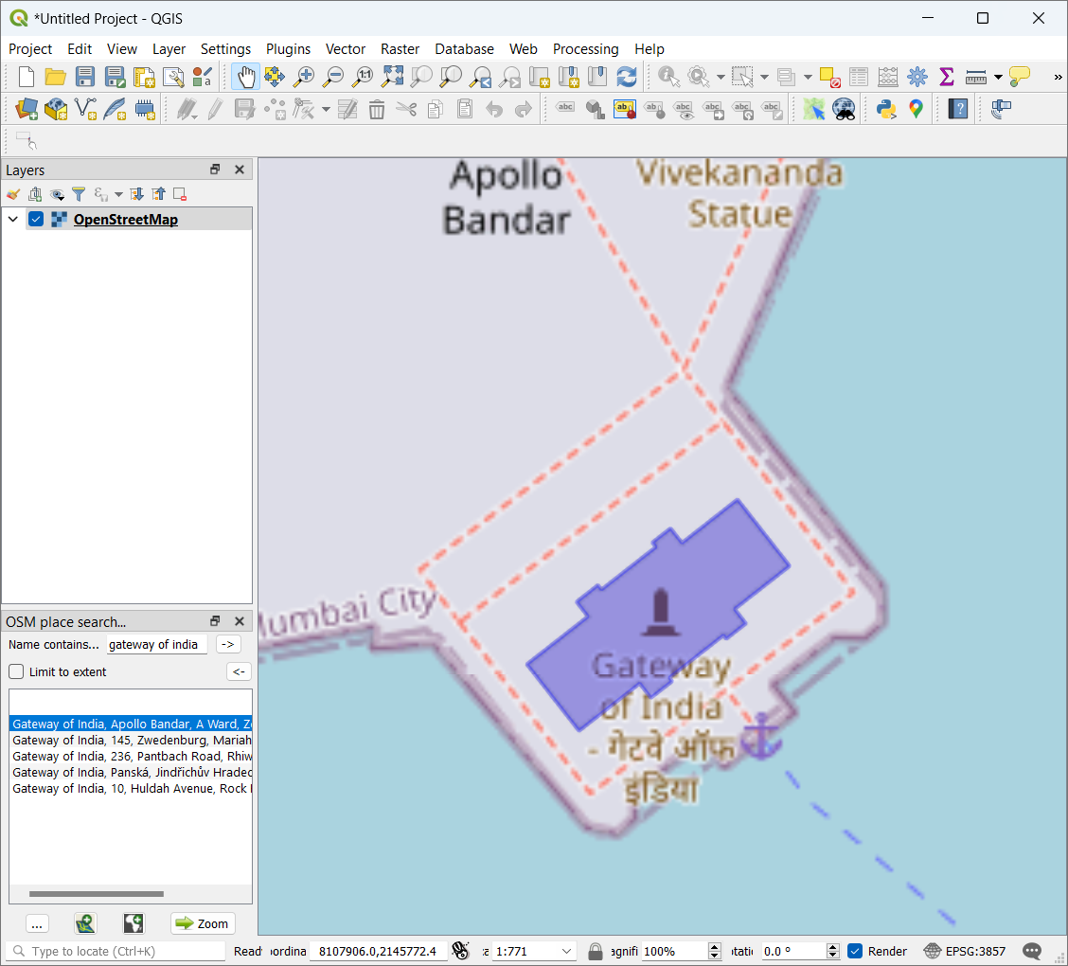

* Go to Raster → Georefrencer

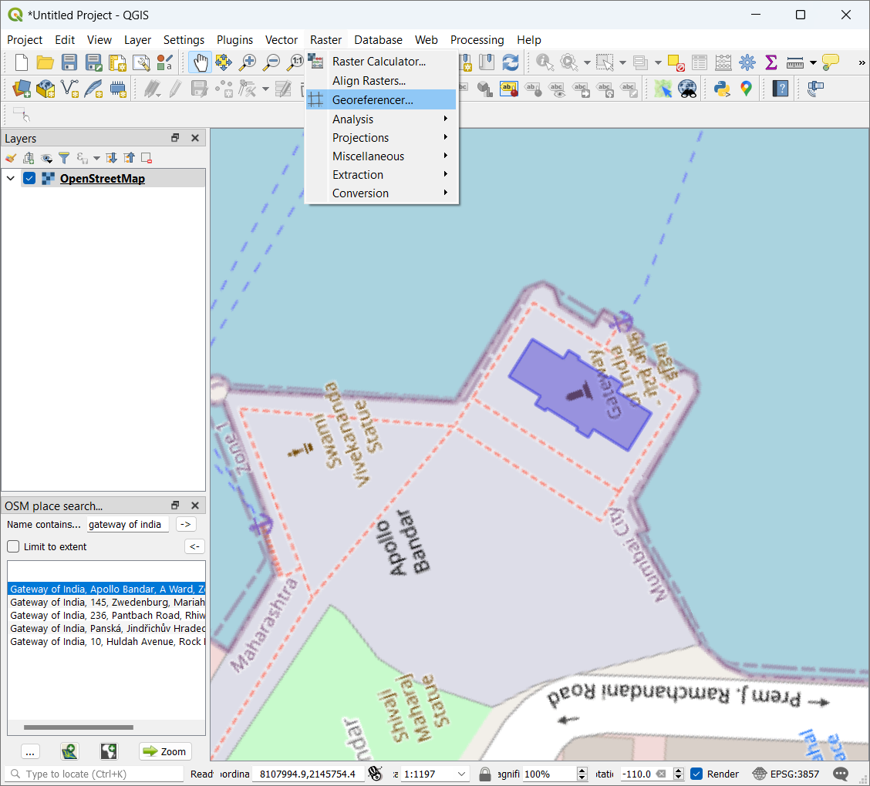

* A new Georeferencer window will open
* File --> Open Raster

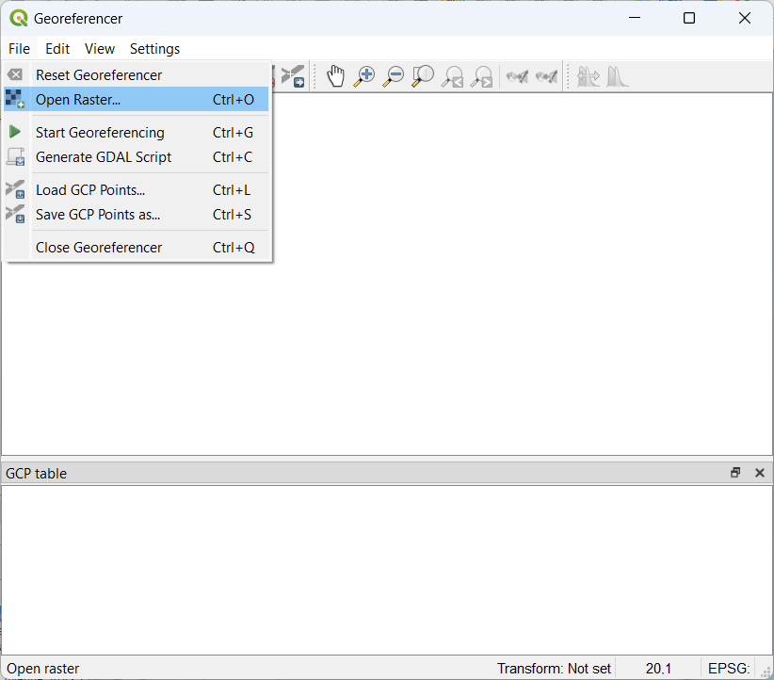

* Select file “Gateway_Imagery.tif”

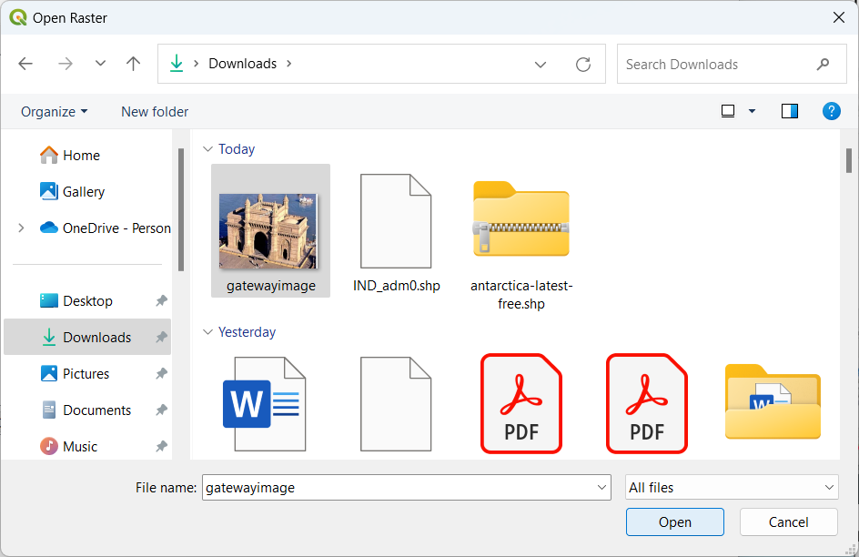

* Go to Settings →Transformation Settings

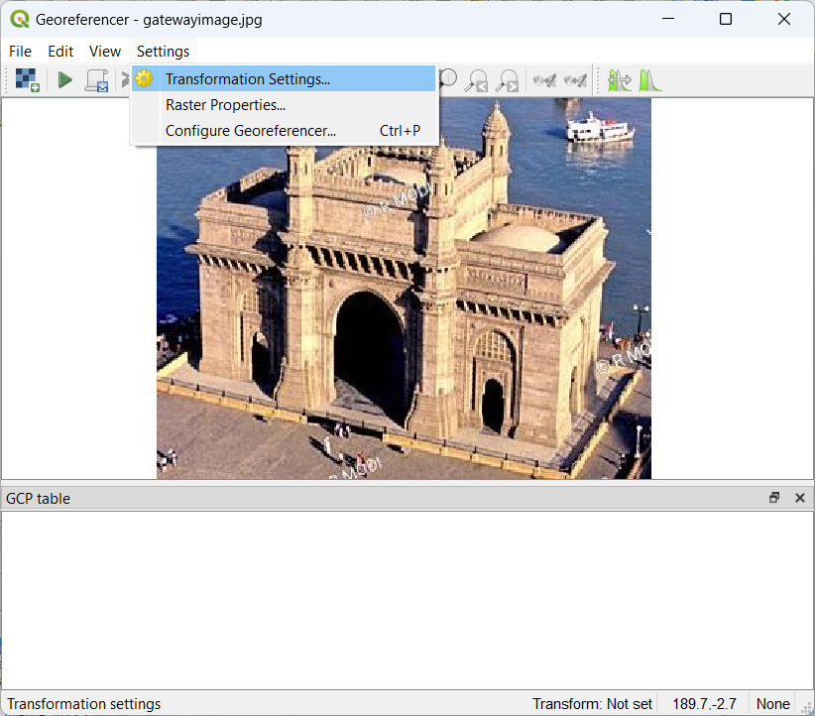

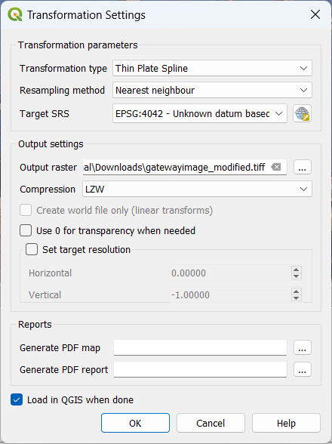

* Go to Edit → Add Point

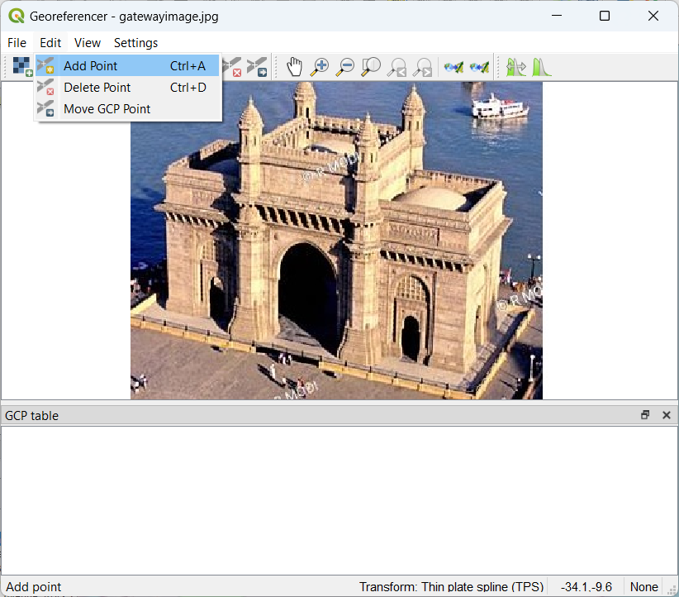

* Select the set of control points.

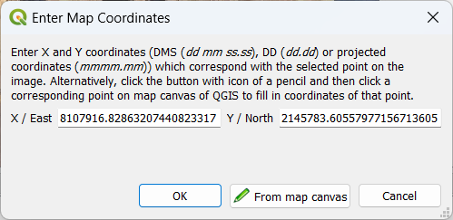

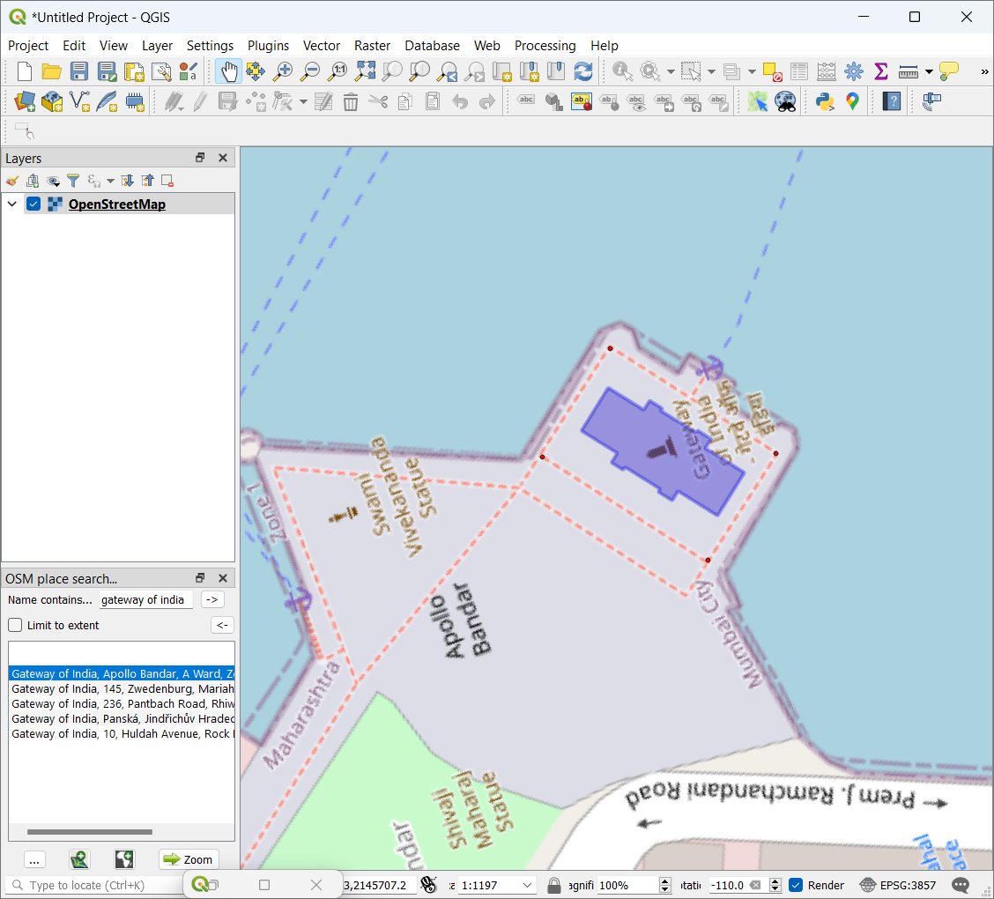

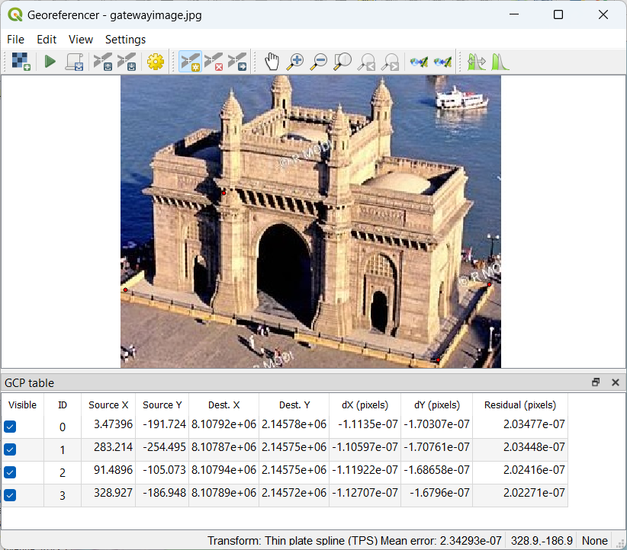

* Go to File → Start Georeferencing or Press the button in Georegerencing Window.
* The progress indicator will appear

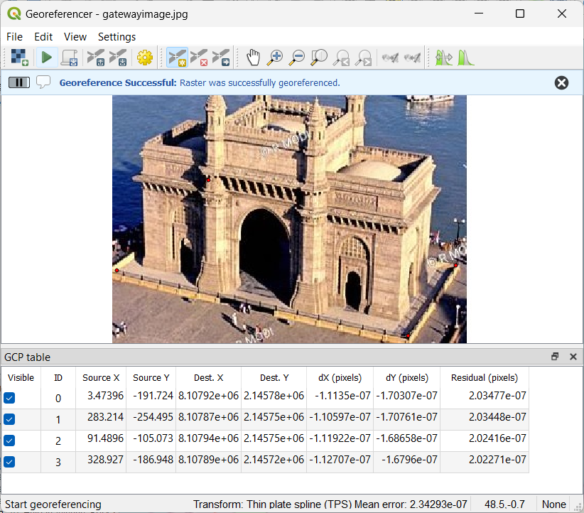



* Observe that the aerial image of the Gateway of India is georeferenced on OSM in the map canvas.

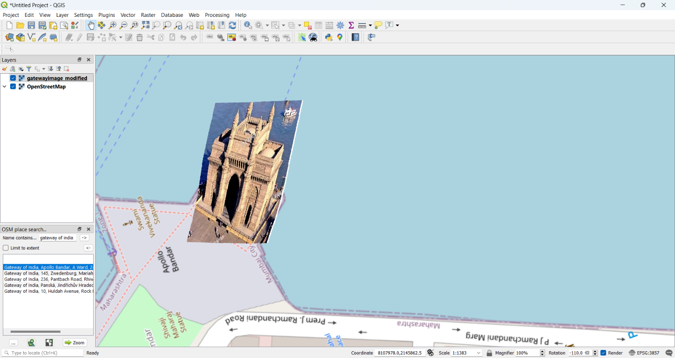

**Conclusion:** The above project has been performed and executed successfully.